**Model Development Phase Template**

| Date | 20 july 2024 |
| --- | --- |
| Team ID | Team-740034 |
| Project Title | Predicting the energy output of wind turbine based on weather conditions. |
| Maximum Marks | 10 Marks |

**Initial Model Training Code, Model Validation and Evaluation Report**

The initial model training code will be showcased in the future through a screenshot. The model validation and evaluation report will include a summary and training and validation performance metrics for multiple models, presented through respective screenshots.

**Initial Model Training Code (5 marks):**

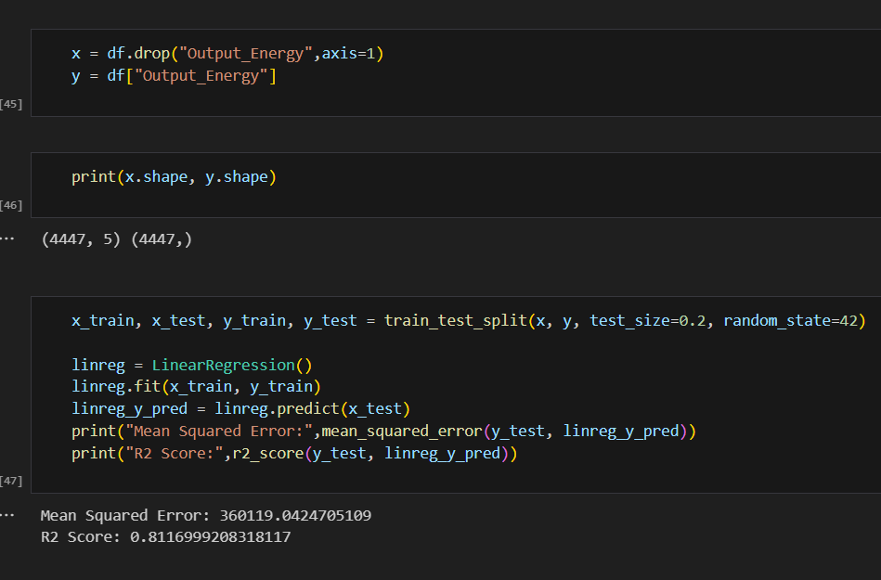

**Model Validation and Evaluation Report (5 marks):**

| **Model** | **Summary** | **Training and Validation Performance Metrics** |
| --- | --- | --- |
| Randomforest | Screenshot 2024-07-21 192744.png | Screenshot 2024-07-21 192752.png |
| GradientBoostingRegression | Screenshot 2024-07-21 192801.png | Screenshot 2024-07-21 192752.png |